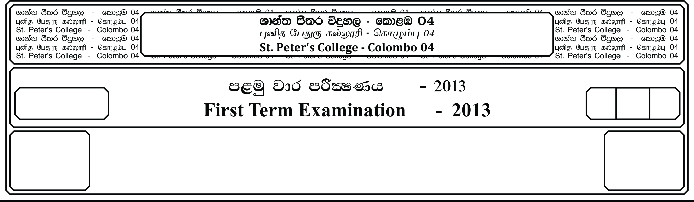

13 fY%aKsh

GRADE 13

13

meh 02

02 Hours

I

**m<uq jdr mÍCIKh - 2024**

**First Term Examination - 2024**

idudkH bx.%Sis - ¸

**GENERAL ENGLISH - I**

E

**Part - I**

**01. Fill the blanks with the following preposition. You can use more than ones.**

(around , over , of , to , in , between)

Globalization is a process **(1).** _______________ advancement and increase **(2).** _______________ interaction **(3).** _______________ the world’s countries and people. It involves **(4).** _______________ locomotion, communication, knowledge and skills. Globalization is gaining spleen **(5).** _______________ the entire world. However, there are poor countries its taken as a big problem **(6).** _______________ their country. People in these countries are unskilled due **(7).** _______________the lack **(8).** _______________ knowledge and equipment. Globalization also encourage crimes like the illegal drug trafficking **(9).** _______________ the world. This has affected a lot **(10).** _______________ problems to the country. ***(10 Marks)***

**02. Fill the blanks with the correct verb given in brackets.**

One of the one hand education **(1).** _______________ **(be)** highly **(2).** _______________ **(recommend)** skill in the **(3).** _______________**(develop)** countries, on the other hand the highest wish of many people in regions of poverty. But what **(4).** _______________ **(make)** education to the key factor for the development of a country? We must acknowledge the education **(5).** _______________ **(be)** something that all we need. The differences **(6).** _______________ **(be)** just want we learn. Mostly the **(7).** _______________ **(limit)** educational horizons of poor and less **(8).** _______________ **(educate)** people have more to deal with their personal situation than with problems of bigger effects on a country. **(9).** _______________ **(attend)** school is something too expensive and it **(10).** _______________ **(not)** feed a family. ***(10 Marks)***

**03. Complete the gaps with the correct word in bracket.**

Healthy eating and keeping physically active are **(1).** _______________ **(particular)** important for children and adolescents. Their nutrition and lifestyle have a direct impact on their **(2).** _______________ **(grow)** and development. Moreover, world wide trends in obesity in children and teenagers are becoming **(3).** _______________ **(increase)** worrying. Being overweight or obese has been linked to a greater **(4).** _______________ **(occur)** of various health complaints later in life. One way to improve the dietary habits of school children is to make **(5).** _______________ **(adjust)** to the food served for lunch. ***(05 Marks)***

**04. Underline the correct answer.**

1. I haven’t seen him (late / lately)

2. He looked at us. (cold / coldly)

3. They came (direct / directly) after breakfast.

4. I need this money (badly / bad)

5. It was a (slow / slower) train. ***(05 Marks)***

**05. Match the clauses to make complete sentence.**

1. He didn’t understand, A. but he wasn’t given access to the room.

2. He was told to behave, B. because he can influence people to do anything.

3. Joe was such a bad person C. because the impending test was so important.

4. To keep the jewels safe, D. so the constant music wouldn’t annoy the neighbours.

5. Be careful E. that he broke every law.

6. Mark tried the cord F. because there were cracks in it

7. She practices the violin during the day G. so he conduct was excellent

8. He studied hard H. It was enclosed in glass

9. She turned her phone off, I. so they told him a different version

10. He replaced the glass J. So the mode wouldn’t disturb anyone.

***(10 Marks)***

**06. Read the passage and write the correct answer.**

What is a job interview? Well, generally it is what follows after you have sent you CV to an employer who wants to know more about you. Nowadays, employers want to meet you in person and see what you look like and discuss your qualifications. There are several things you have to be careful about for example, the way you dress for the first meeting. For men, it is better to wear formal clothes – a shirt, tie and it is appropriate to wear a jacket or blazer, it is important to look smart and not wear too much make-up! Another important point is punctuality. Make sure you arrive on time never be late! They may think you are not very reliable. When you are in the actual interview answer the questions clearly and directly and, if there is something you do not understand, ask them to repeat the question instead of giving the wrong answer. Show that you are interested in the job but do not be ever excited. Relax, do your best and be yourself!

**Circle T (true) or F (false)**

1. An interview happens before giving your CV T F

2. The employers like to meet you T F

3. It doesn’t matter what you look like T F

4. Men should wear a shirt and tie T F

5. The more make-up a woman wears the better T F

6. Punctuality is very important T F

7. All answers must be clear and direct T F

8. Be honest if you don’t understand the question T F

9. What are the most important factors you should be concerned

when facing a job interview ___________________________________________________

__________________________________________________________________________

10. Write the opposite of the following words.

Formal - __________________________

Appropriate - __________________________

Reliable - __________________________

Direct - __________________________

***(10 Marks)***

**07. Write a paragraph beginning with following sentence. (in 75-100 words)**

Nowadays, there is a trend that reports of media focus on problems and emergencies rather than positive development ___________________________________________________________

________________________________________________________________________________________________________________________________________________________________________________________________________________________________________________________________________________________________________________________________________________________________________________________________________________________________________________________________________________________________________________________________________________________________________________________________________________________________________________________________________________________________________________________________________________________________________________________________________________________________________________________________________________________________________________________________________________________________________________________________________________________________________________________________________________________________________________________________________________________________________________________________________________________________________________________________________________________________________________________________________________________________________________________________________________________________________________________________________________________________________________________________________________________________________________________________________________________________________________________________________________________________________________________________________________________________________________________________________________________________________________________________________________________________________________________________________________________________________________________________________________________________________________________________________________________________________________________________________________________________________________________________________________________________________________________________________________________________________________________________________________________________________________________________________________

***(10 Marks)***